Select View is very awkward on large number of models, cubes and views
We need some options to control the volume of selections that appear when you have numerous models to select from. While it is likely that most customers will not have as many models as professional consultants or Presales. It is not helping in the acquisition of new customers to always must explain that their UI will not look as bad as the one we are showing right now.
Select View in Excel
Problem with Views cubes and views going on and on and on in Select view. You see below when you select a view you really have to drill down to get to what you want to access. The new search helps, but better would be to have less to navigate in the first place.
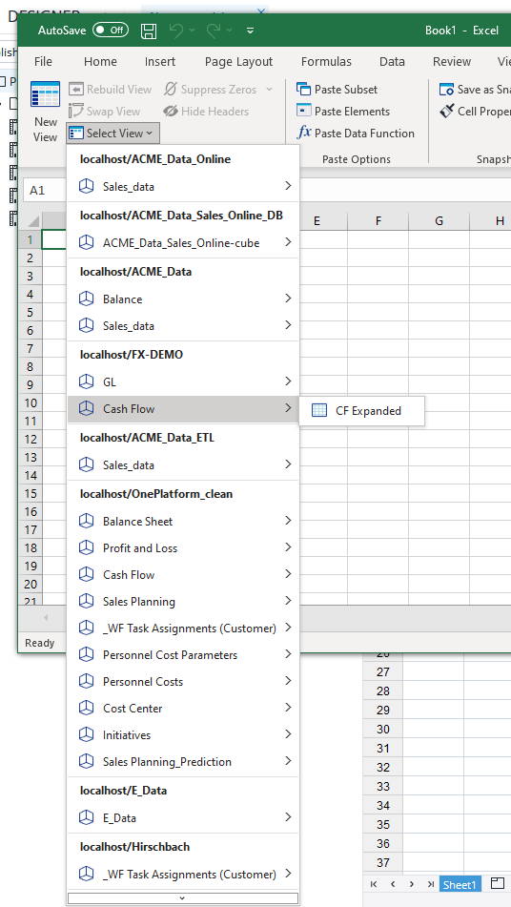
Select View in Edit View
Same issue as above, but worse now as all the cubes are expanded to show everyview in the cube.
This will impact customers as well as they may have dozens of views. The Select view is at least better in that it is tighter than this one.
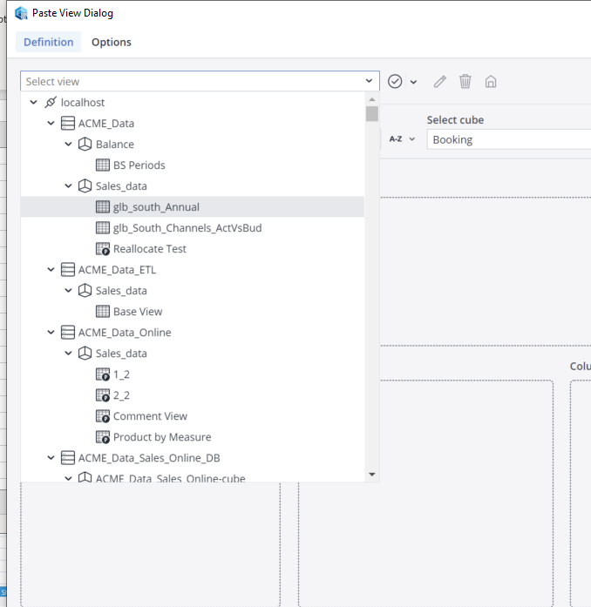
Select View in Jedox Cloud Report
Select View in the cloud is worse than it is in Excel as it is mirroring the same issue you see in the Edit View above. So it gets very unwieldy when presented with numerous views.
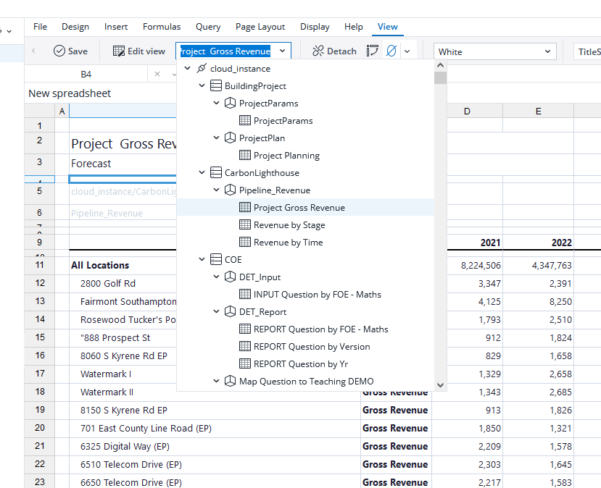

Solution suggestions
- One thought is to have Pined objects(for cubes and views) like we do in Web. (but not the only possible solution)
Then allow the users to only show Pinned objects with and options to “Show All” One could custom what they want to have appear.
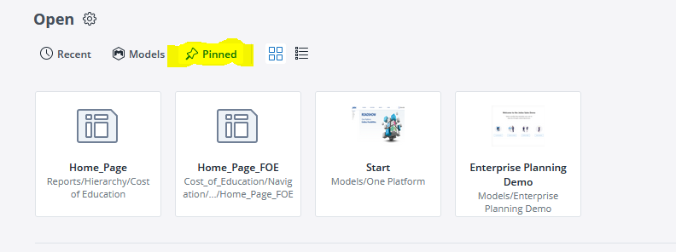

- Another thought is to set the default, so the hierarchies are by default collapsed. It is much easier to navigate this way.
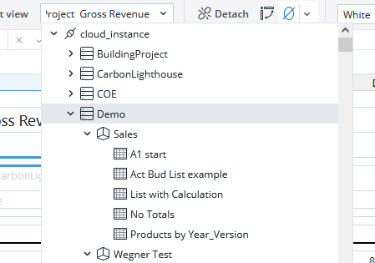
Combine the always collapsed with Pinned views concept and you could have the one you want to always show up stick out. You could imagine that the user set the five views under Sales as Pined, but there are more available if they collapse and expand the Sales cube again.

