Associate Select View with the cube already selected
If you select Cube and database already, why does the Select view drop you in the middle of all databases?
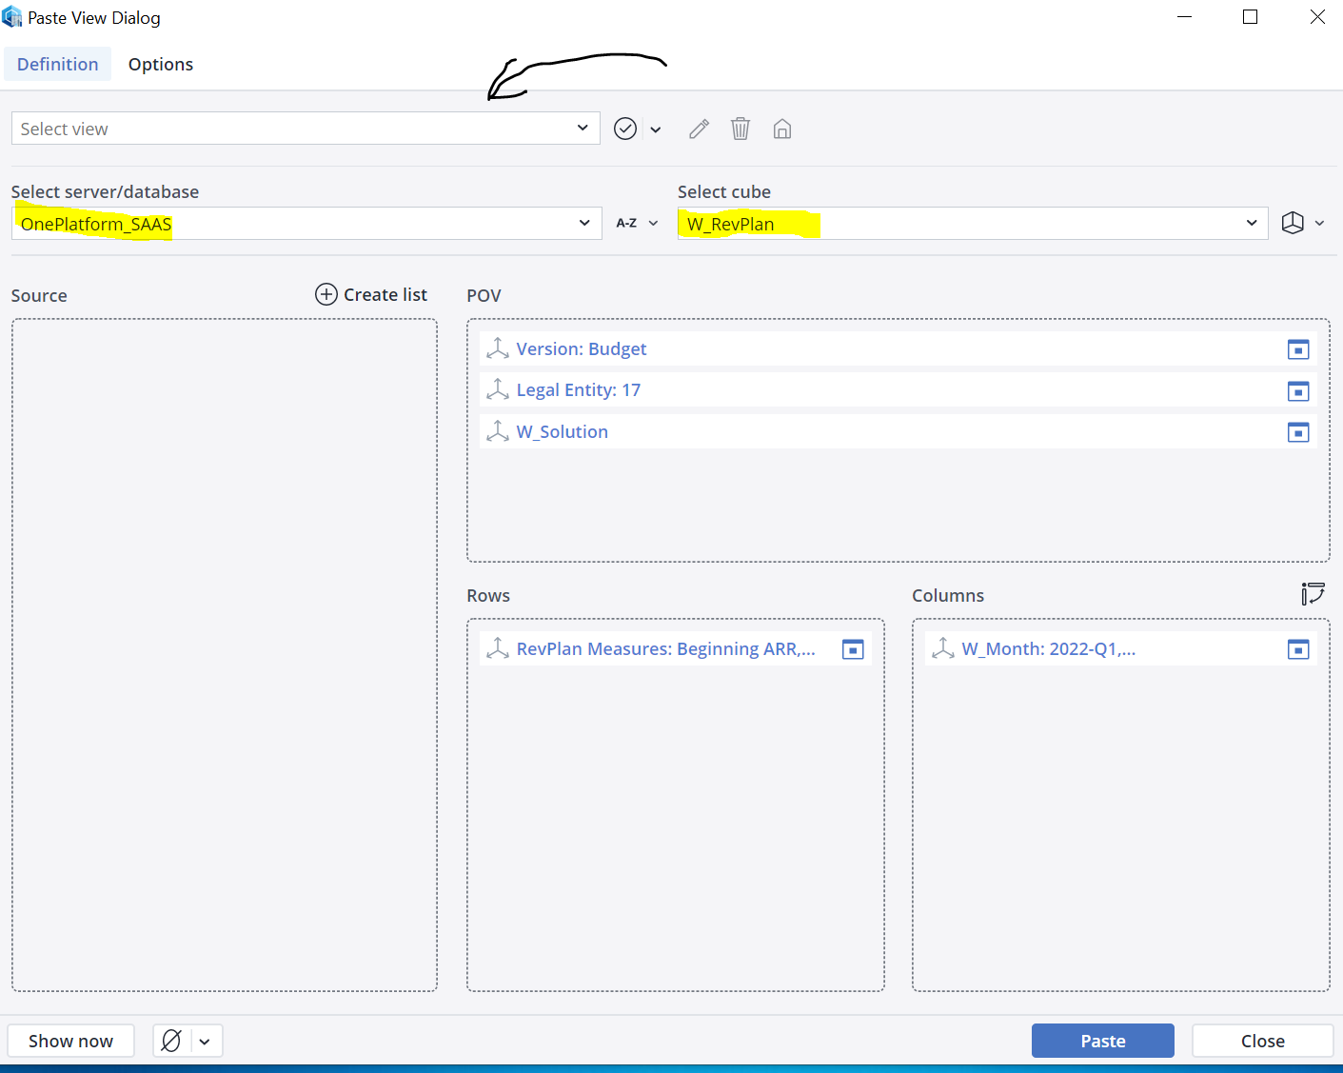
It should give you instead by default the list of views associated with that cube!
Not force you to go hunt for the view among multiple databases.
